UNIVERSIDADE DE SÃO PAULO
Faculdade de economia, administração, contabilidade e atuária
Departamento de Economia
Economia do Trabalho I - EAE0509
Profa. dra. Solange Ledi Gonçalves

Choques nos Salários com a Tragédia de Brumadinho

Hugo Santana Figueiredo Neto - 12511750
Lucas Kusakabe Bahia - 125111336
João Mendonça Marrey - 12511600

2024

INTRODUÇÃO

On the 25th of January 2019, one of the biggest socioenvironmental catastrophes of Brazil happened: the collapse of the dam of the Córrego Feijão iron mine at the city of Brumadinho, Minas Gerais state (MG). The accident led to 272 deaths, a number approximately 18 times bigger than the Mariana disaster in 2015, a similar incident. More than 11.7 million m³ of toxic mud raged through the region and contaminated the Paraopeba River.
Among the reasons that lead to the collapse is the structure of the dam. The Brumadinho dam was operated by the Brazilian mining company Vale S.A. since 1976, it was built as an upstream tailings dam, which is frailer if compared to centreline and downstream tailings dam design (Figure 1).
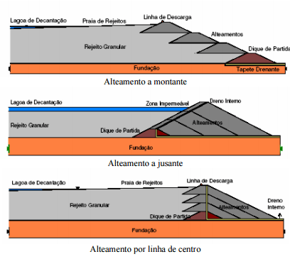
Figura 1: Estrutura das barragens de alteamento a montante, a jusante
e por linha de centro
Besides, the BBC Brasil stated that since 2016 the dam had been without inspection by the ANM (Brazilian National Mining Agency). Furthermore, in the same year, there was a change in the internal inspection from the Tractebel to the Tüv Süd agency done by Vale after the former pointing out the risk of collapse, a different assessment than that of the new agency.
Due to the accident, and to make reparations, the company has compensated 15.4 thousand families and eliminated 13 other upstream dams which remain inactive and represent 40% of the dams which are supposed to be closed until the end of 2035 in Vale’s De-characterization program, also adopting a better residual filtration system, decreasing its build up to up to 80%. Another measure was compromising to allocate 38 billion reais (BRL) in a judicial agreement for socioeconomic and environmental reparations in the region.
This work intends to analyze, through an econometric approach, the impact that the collapse had on the region’s labor market of Brumadinho and other affected municipalities, focusing on the wage level. This approach is necessary because the net effect of the disaster on the wages is not obvious, despite it being expected that the accident impacted negatively on the wages at first, with the financial reparations and incentives given to families by Vale, the net effect is uncertain.

REVISÃO DA LITERATURA
The impacts of this tragedy go much further beyond the scope of this paper. Previous literature indicates that 51% of the 297.28 hectares of environmental devastation used to be preserved forest area (Pereira, 2019). In addition, the contamination of the Paraopeba River Basin exceeded by many times the threshold for toxic substances, such as the heavy metals Manganese and Cadmium (Polignano, 2020). There were more than 3845 people affected directly (Freitas, 2019), among which the very workers of Vale, which represented 91% of the deaths of the tragedy (Silva, 2020).
Works with a more empirical approach find relevant negative impacts for the affected population. General equilibrium models using simulations to try and predict the impact of the tragedy over the economy, found significant negative impacts on the short term (dasilva2021 brumadinho).
This paper also takes big inspiration in the work of (Matsunaga 2020), which tries to explore the effect of the Mariana dam collapse over mental health and finds an increase in the number of hospitalizations by mental health disorders in the affected population using a differences-in-differences framework. We use similar empirical models, but analyze a different disaster and the labor market instead of the mental health disorders.

BASE DE DADOS E MATCHING
We defined three different groups of affected municipalities, treated groups, against which we will test the results. This division is made so that we can consider the heterogenous treatment effects between these groups, since the mud did not affect every location in the same manner and intensity, e.g. cities closer to the dam would receive stronger mud inflow. The groups are:
- Group 1: Composed only by the city of Brumadinho, which is the only place where the mud caused physical damage, besides the river contamination.
- Group 2: Cities downstream of the Paraopeba River which were closer to Brumadinho. Contains the municipalities of Betim, São Joaquim de Bicas, Igarapé and Mário Campos.
- Group 3: Cities downstream of the Paraopeba River which were further away from Brumadinho. Contains the municipalities of Juatuba, Florestal, Pará de Minas, Esmeraldas, São José da Varginha, Pequi, Fortuna de Minas, Maravilhas, Papagaios, Paraopeba, Pompéu and Curvelo.

To perform the matching between the municipalities and select the control group, cities with similar characteristics but that were not affect by the disaster, we used data from IBGE (Brazilian Geography and Statistics Institute) and DATASUS (a database for the unified Brazilian health care system). We consider variables such as population, GINI index and HDI, as well as economic variables such as GDP per capita, percentage of poor and extremely poor population and composition of the added value of the economy by sector (Figure 2).

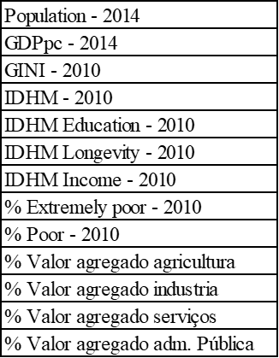
Figura 2: variáveis utilizadas no matching
Our matching approach was to create a model that searches for the nearest neighbors to each treated municipality (affected by the dam) by minimizing the differences in these variables between non treated municipalities in the same state. We opted out of using Propensity Score Matching (PSM) since one of the defined treatment groups contains only a single treated unity, which leads to statistical limitations in the use of a probabilistic regression.
Analyzing the resulting control group generated by the matching for Brumadinho, we find that most of the control municipalities are also mining cities, with the company Vale operating in them. That is a good indication that the matching process is valid, because it has returned cities with similar socioeconomic characteristics to the treated.
In this work, we have applied the matching process separately for each treated city, choosing the 5 most similar municipalities to the treated one, according to the matching algorithm, as its control group. In case two or more municipalities of the same group share a common city in their control groups, this city is only used once as a counterfactual, not being repeated on the database.

MODELO
For each group, we use differences-in-differences models to evaluate the impact of the disaster on our interest variable, represented by the log of the average monthly wage for the month of December of each year. We use data from the RAIS, a public database containing extremely detailed socioeconomic data for the entirety of Brazil, for the period between 2015 and 2022 for our analysis. Four specifications are used:
(1) Homogenous Effect: Treatment effect constant in time
$$Y_{it} = ꞵ+α_{i}+α_{t}+ϕ+ e_{it}$$

- (2) Post Treatment Heterogenous Effect: Treatment effect varying in time 2019-2022
$$Y_{it} = ꞵ+α_{i}+α_{t}+ϕ_{2019}+ϕ_{2020}+ϕ_{2021}+ϕ_{2022}+ e_{it}$$

- (3) Pre and Post Treatment Heterogenous Effect: Treatment effect varying in time 2019-2022 and dummies for placebo test 2015-2017
$$Y_{it} = ꞵ+α_{i}+α_{t}+ϕ_{2015}+ϕ_{2016}+ϕ_{2017}+ϕ_{2019}+ϕ_{2020}+ϕ_{2021}+ϕ_{2022}+ e_{it}$$

- (4) Callaway Sant’Anna: Here we make an additional robustness test using the (Callaway Sant’Anna 2021) estimator. Similarly to the third specification, the treatment coefficients for 2019 through to 2022 are reported, as well as the placebo tests. However, the test coefficients span from 2016 through to 2018, with the base year, i.e. year with the treated dummy omitted to avoid the “dummy trap”, being 2015, while on the third specification it was 2018.

$i$ - é o indexador de município.
$t$ - é o indexador de tempo.
$Y_{it}$ - representa a variável de interesse que é o log do salário mensal a cada ano no mês de dezembro.
$ꞵ$ - representa o intercepto da regressão.
$α_{i}$ - representa o efeito fixo de município.
$α_{t}$ - representa o efeito fixo de tempo.
$ϕ$ - representa o efeito de tratamento, ter sido afetado pelo acidente.
$ϕ_{2015}$ - representa o efeito de tratamento em 2015.
$ϕ_{2016}$ - representa o efeito de tratamento em 2016.
$ϕ_{2017}$ - representa o efeito de tratamento em 2017.
$ϕ_{2019}$ - representa o efeito de tratamento em 2019.
$ϕ_{2020}$ - representa o efeito de tratamento em 2020.
$ϕ_{2021}$ - representa o efeito de tratamento em 2021.
$ϕ_{2022}$ - representa o efeito de tratamento em 2022.
$e_{it}$ - representa o termo de erro.

APRESENTAÇÃO DOS RESULTADOS
We display the results for every group and for each specification of the differences-in-differences model.
The first group contains only the city of Brumadinho, the most affected by the accident.

GRUPO 1 - Brumadinho
Variável Dependente | (1) Efeito Homogêneo | (2) Efeito Heterogêneo Pós Desastre | (3) Efeito Heterogêneo Pré e Pós Desastre | (4) Callaway Sant’Anna
$$ϕ$$ | -0.067027*  (0.034632) | - | - | -
$$ϕ_{2015}$$ | - | - | 0.104564*  (0.059531) | -
$$ϕ_{2016}$$ | - | - | 0.075317*  (0.041148) | -0.0292  (0.0572)
$$ϕ_{2017}$$ | - | - | 0.018609  (0.046944) | -0.0567  (0.0392)
$$ϕ_{2018}$$ | - | - | - | -0.0186  (0.0306)
$$ϕ_{2019}$$ | - | -0.126005***  (0.032256) | -0.076383**  (0.038872) | -0.0764***  (0.0259)
$$ϕ_{2020}$$ | - | -0.069234**  (0.029177) | -0.019612  (0.036078) | -0.0196  (0.0243)
$$ϕ_{2021}$$ | - | -0.010196  (0.040665) | 0.039426  (0.046796) | -0.0394  (0.0543)
$$ϕ_{2022}$$ | - | -0.062672*  (0.032005) | -0.013049  (0.038641) | -0.0130  (0.0410)
Observações | 48 | 48 | 48 | 48
$$R^{2}$$ | 0.948524 | 0.951168 | 0.953957 | -
$R^{2}$ ajustado | 0.928842 | 0.925964 | 0.922714 | -
Nota: *p<0.1; **p<0.05; ***p<0.01 - Erros Padrão Robustos a Heterocedasticidade em parênteses.

In the first regression specification, we see a negative effect over the wages, but it is insignificant at 5%. It is Worth noting that this is not the best specification, because it does not allow for the treatment effect to be heterogenous through time.

In the second specification, the impact is still negative, remaining statistically significant for the years of 2019 and 2020, but turning insignificant in 2021 and 2022, with the peak of the effect in 2019. These results are in agreement with what was expected, since the impact is much greater in the year of 2019 and seem to decay throughout time. At the appendix, in Figure A.1, it is possible to visualize a graph displaying the coefficients together with a 95% confidence interval.
In the third specification, we see that 2019 remains a statistically significant negative impact, but the estimated effect is smaller than on the second specification. Besides, the treatment effect stops being significant in 2020, possibly due to the loss of degrees of freedom, due to a greater number of coefficients. The main result for this model, however, is that the coefficients before 2019, the year of the accident, are all insignificant at 5% levels, indicating that the hypothesis of parallel tendencies is being respected. We can visualize the evolution of the coefficients in Figure 2.
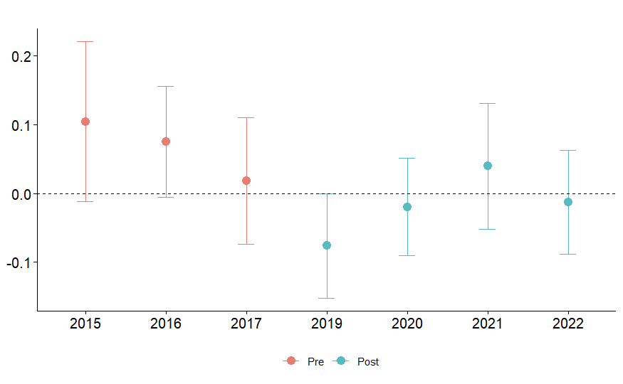
Figura 3: Coeficientes estimados para Grupo 1 & Especificação 3
Lastly, we report the Callaway Sant’Anna specification as a robustness test for the analysis. We can see that it gets to very similar results to those of the third specification, with the effect in 2019 being even more significant than before, and the placebo test indicating the existence of parallel tendencies. In the appendix, it is possible to see a graph with the results on Figure A.2, indicating that the only statistically significant coefficient is the one from 2019.
It is important to note that the preferred specification is the second one, because the parallel tendencies hypothesis appears to be respected, as shown by the insignificance of the pretreatment dummy coefficients in the third and fourth specifications. Thus, we can take the placebo test out of the regression, gaining degrees of freedom while maintaining our trust on the non-bias of the estimators.

The second group contains cities downstream of the river that were closer to the place of the accident.

GRUPO 2 - Betim, São Joaquim de Bicas, Igarapé e Mário Campos
Variável Dependente | (1) Efeito Homogêneo | (2) Efeito Heterogêneo Pós Desastre | (3) Efeito Heterogêneo Pré e Pós Desastre | (4) Callaway Sant’Anna
$$ϕ$$ | -0.030624  (0.036593) | - | - | -
$$ϕ_{2015}$$ | - | - | 0.002515  (0.042928) | -
$$ϕ_{2016}$$ | - | - | -0.038329  (0.036845) | -0.0408  (0.0233)
$$ϕ_{2017}$$ | - | - | -0.014041  (0.028470) | 0.0243  (0.0216)
$$ϕ_{2018}$$ | - | - | - | 0.0140  (0.0141)
$$ϕ_{2019}$$ | - | -0.009051  (0.037644) | -0.021515  (0.040596) | -0.0215  (0.0296)
$$ϕ_{2020}$$ | - | -0.013784  (0.030011) | -0.026248  (0.033466) | -0.0262  (0.0246)
$$ϕ_{2021}$$ | - | -0.005298  (0.116450) | -0.017762  (0.118598) | -0.0178  (0.1382)
$$ϕ_{2022}$$ | - | -0.094362*  (0.049009) | -0.106825**  (0.051527) | -0.1068**  (0.0410)
Observações | 168 | 168 | 168 | 168
$$R^{2}$$ | 0.916781 | 0.918906 | 0.919316 | -
$R^{2}$ ajustado | 0.900017 | 0.900422 | 0.898690 | -
Nota: *p<0.1; **p<0.05; ***p<0.01 - Erros Padrão Robustos a Heterocedasticidade em parênteses.

We can see that the coefficients of the first and second specifications are not statistically significant, indicating that there was no impact on the log of the wages post disaster. In the appendix Figure A.3 we are able to visualize the coefficients for the second specification, seeing that the 0 value axis is inside of the confidence interval for all of them.
In the third specification, we observed that the parallel tendencies also seem to be valid. The only significant coefficient is the one for 2022, that is unexpected, since there seems to be an effect for this year and not for 2019, however it is probably related to the greater instability of the estimators due to the loss of degrees of freedom if compared to the second specification. In Figure 3 we can analyze the coefficients and that only 2022 has a significant effect at 5%.
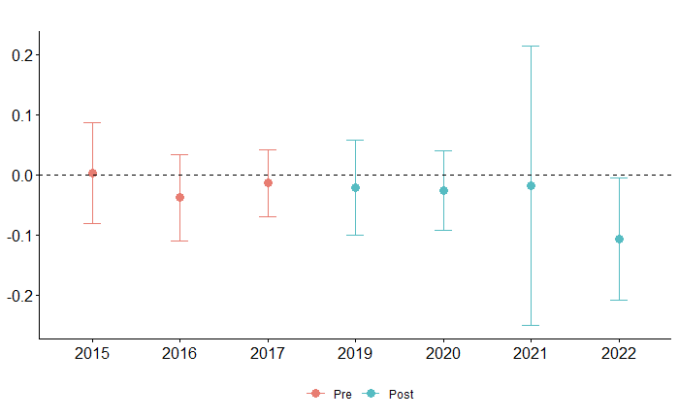
Figura 4: Coeficientes estimados para Grupo 2 & Especificação 3
In the fourth specification we use the Callaway Sant’Anna estimator to verify the robustness of the results. We obtain almost the exact same conclusions as the third specification: the parallel tendencies seem to be respected and only the coefficient for 2022 is significant at 5%. In the appendix Figure A.4 we have a graph of the coefficients with their confidence intervals. Notice that it is very similar to the one of the third specification.
As the parallel tendencies seem to be respected, the preferred specification becomes again the second one. With that, we conclude that there were no statistically significant effects over the second group, related to the collapse of the dam.
The third group contains cities downstream of the river that were far to the place of the accident.

GRUPO 3 - Juatuba, Florestal, Pará de Minas, Esmeraldas, São José da Varginha, Pequi, Fortuna de Minas, Maravilhas, Papagaios, Paraopeba, Pompéu e Curvelo
Variável Dependente | (1) Efeito Homogêneo | (2) Efeito Heterogêneo Pós Desastre | (3) Efeito Heterogêneo Pré e Pós Desastre | (4) Callaway Sant’Anna
$$ϕ$$ | -0.001845  (0.017020) | - | - | -
$$ϕ_{2015}$$ | - | - | -0.035515  (0.032130) | -
$$ϕ_{2016}$$ | - | - | -0.026895  (0.026551) | 0.0086  (0.0318)
$$ϕ_{2017}$$ | - | - | -0.019906  (0.022496) | 0.0070  (0.0182)
$$ϕ_{2018}$$ | - | - | - | 0.0199  (0.0257)
$$ϕ_{2019}$$ | - | 0.012084  (0.020090) | -0.008495  (0.022879) | -0.0085  (0.0136)
$$ϕ_{2020}$$ | - | 0.000136  (0.020843) | -0.020443  (0.023547) | -0.0204  (0.0207)
$$ϕ_{2021}$$ | - | 0.009776  (0.040179) | -0.010803  (0.041738) | -0.0108  (0.0510)
$$ϕ_{2022}$$ | - | -0.029376  (0.027895) | -0.049955*  (0.030007) | -0.0500*  (0.0285)
Observações | 544 | 544 | 544 | 544
$$R^{2}$$ | 0.917183 | 0.917569 | 0.917812 | -
$R^{2}$ ajustado | 0.903911 | 0.903742 | 0.903402 | -
Nota: *p<0.1; **p<0.05; ***p<0.01 - Erros Padrão Robustos a Heterocedasticidade em parênteses.

In the model of the first specification, we see that the estimated coefficient is statistically insignificant at 5%. In the second specification, we relax the hypothesis of treatment constant in time, however, all of the coefficients are not only statistically insignificant, but also the ones from 2019 through to 2021 are also positive, suggesting that they are likely null in reality. In the appendix Figure A.5 it is possible to see a graph of the coefficients of the second specification, notice how all are very close to zero.
In the third specification the parallel tendencies hypothesis seems to be valid and all coefficients continue to be statistically insignificant at 5%. It is possible to visualize the coefficients in Figure 4.

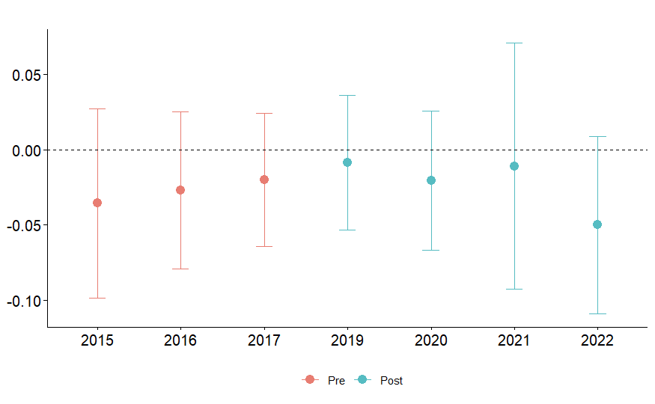
Figura 5: Coeficientes estimados para Grupo 3 & Especificação 3
In the fourth specification we use the Callaway Sant’Anna estimator once again and obtain similar results to the third specification, with parallel tendencies and all of the coefficients statistically insignificant. In the appendix Figure A.6 we can observe the graph of these coefficients.
As in the other groups, the preferred specification is the second, since the parallel tendencies hypothesis seems to be respected. Here the effect appears to be null, with most of the periods even reporting a positive estimated effect, however insignificant.

DISCUSSÃO DOS RESULTADOS E CONCLUSÃO
From the four different specifications and three groups, we can have a clearer view over the impacts of the Brumadinho disaster in the labor market of the affected region. We find a negative effect from the disaster over the log of the average wages in the city of Brumadinho, it indicates a fall of 12.6% of the average monthly wage in 2019, with the gradual dissipation of this effect in the following years.
For the other treatment groups, which include other affected municipalities, but in a lower degree, we do not find any significant effect at 5% confidence level in the second specification. Thus, we are unable to identify any significant impact on the log of the average wages of these municipalities.
It is also important to note that further robustness tests performed, such as the placebo tests and the use of the Callaway Sant’Anna estimator, seem to indicate that the parallel tendencies are being respected and the results are robust.

REFERÊNCIAS
MATSUNAGA, Liz. Disasters and mental health: evidence from the Fundao tailing dam breach in Mariana, Brazil. 2020. Dissertação (Mestrado em Teoria Econômica) - Faculdade de Economia, Administração e Contabilidade, University of São Paulo, São Paulo, 2020.
FREITAS CM et al. 2019. “Da Samarco em Mariana à Vale em Brumadinho: desastres em barragens de mineração e Saúde Coletiva”
SILVA, M. 2020. “Sobreposição de riscos e impactos no desastre da Vale em Brumadinho”
GONZALEZ, R.S., et al. 2021. "Economic and financial consequences of process accidents in Brazil: Multiple case studies."
POLIGNANO, Marcus Vinicius; LEMOS, Rodrigo Silva. Rompimento da barragem da Vale em Brumadinho: impactos socioambientais na Bacia do Rio Paraopeba. Cienc. Cult., São Paulo , v. 72, n. 2, p. 37-43, Apr. 2020.
PEREIRA, L. F., CRUZ, G. de B., & GUIMARÃES, R. M. F. (2019). Impactos do rompimento da barragem de rejeitos de Brumadinho, Brasil: uma análise baseada nas mudanças de cobertura da terra. Journal of Environmental Analysis and Progress, 4(2), 122–129.
CALLAWAY, BRANTKY, and SANT’ANNA. "Difference-in-differences with multiple time periods." Journal of econometrics 225.2 (2021): 200-230.

ANEXO
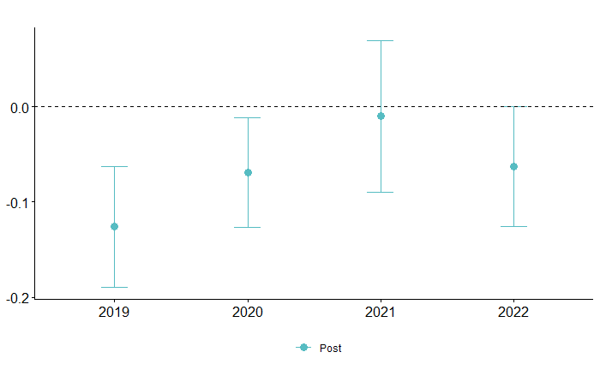
Anexo 1: Coeficientes estimados para Grupo 1 & Especificação 2

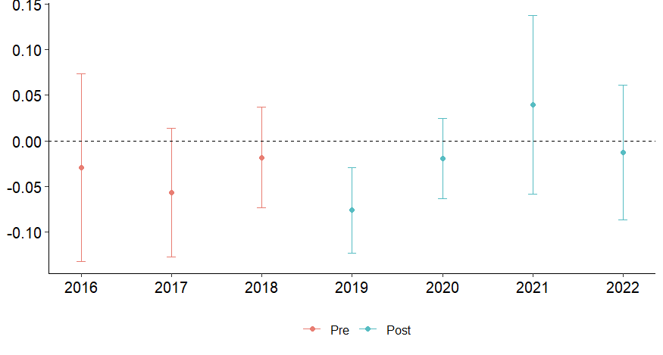
Anexo 2: Coeficientes estimados para Grupo 1 & Especificação 4
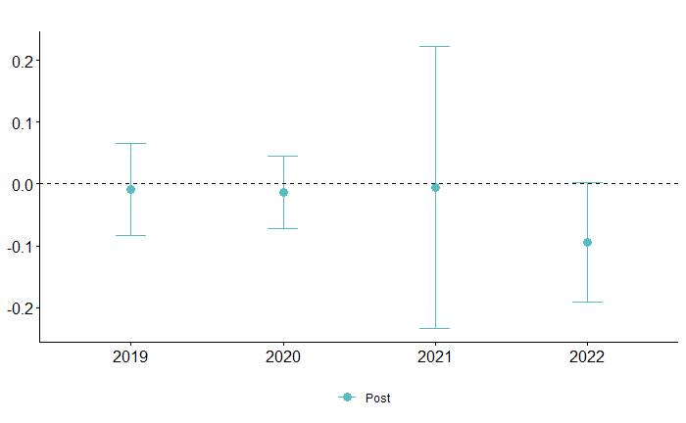
Anexo 3: Coeficientes estimados para Grupo 2 & Especificação 2

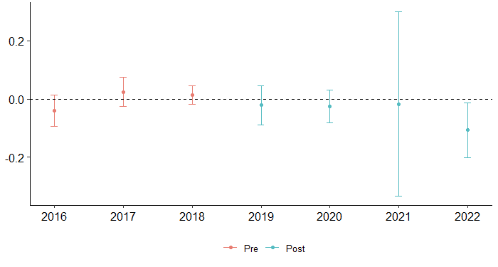 Anexo 4: Coeficientes estimados para Grupo 2 & Especificação 4

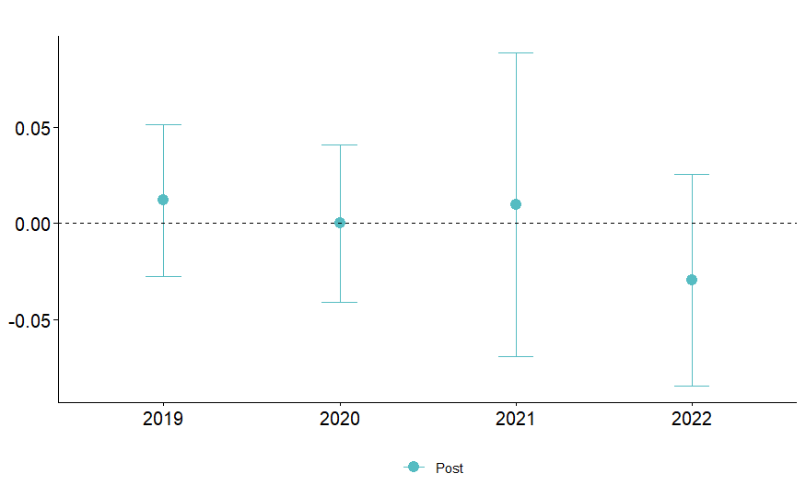
Anexo 5: Coeficientes estimados para Grupo 3 & Especificação 2

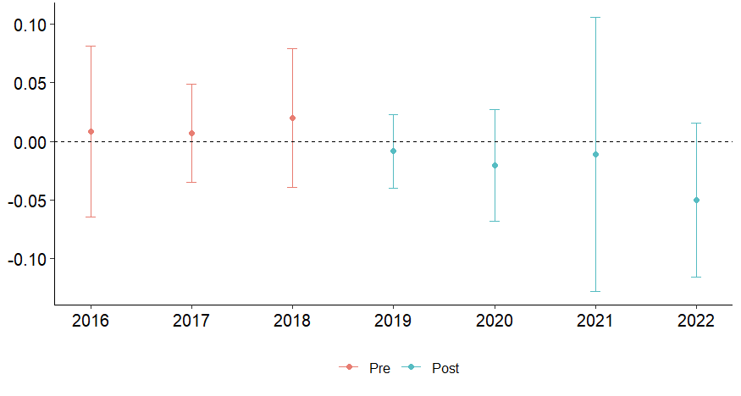
Anexo 6: Coeficientes estimados para Grupo 3 & Especificação 4

